DOI: https://doi.org/xxxxxxxxxxx

Identification of Iraqi Wild Mushrooms

Author Name¹*, Co-author Name²

¹ Affiliation 1  
² Affiliation 2

*Corresponding author: email@example.com

**Abstract**

This is a concise summary of the research, covering objectives, methods, key findings, and conclusions in 200–300 words.

Keywords: Mycology; Truffle; Desert fungi; Biodiversity; Cultivation.

**1. Introduction**

**2. Materials and Methods**

**3. Results and Discussion**

**4. Conclusion**

**Acknowledgements (Optional)**

**References**

**Figure 1**. Sample image of a wild mushroom species:

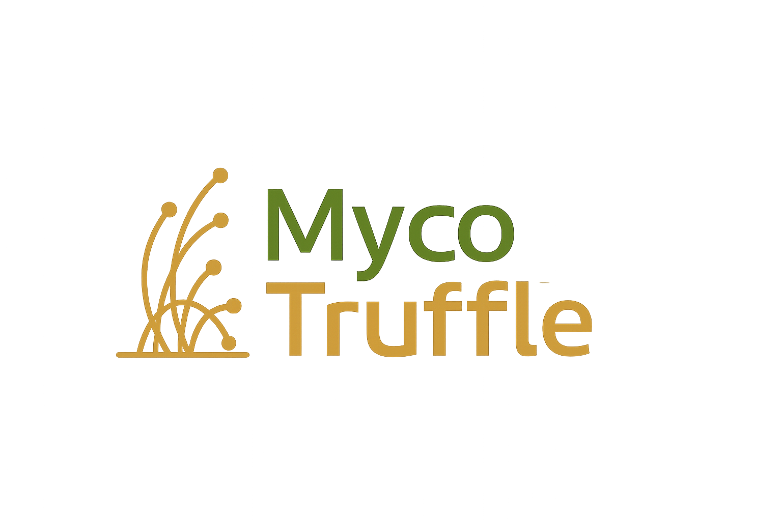

|  |  |  |
| --- | --- | --- |
| Species | Habitat | Observation Date |
| Agaricus sp. | Forest edge | March 2025 |

**How to cite this article:**

Author Last Name, Initials. (Year). Identification of Iraqi wild mushrooms. MycoTruffle – Journal of Mycology and Truffles, Volume(Issue), pages. https://doi.org/xxxxx

**Examples of References:**

- One author: Smith, J. (2023). Mycology studies in desert regions. Mycology Journal, 12(2), 100–110.

- Two authors: Ali, M., & Hussein, R. (2022). Truffle biodiversity in Iraq. Iraqi J. Biol. Sci., 15(1), 50–60.

- More than three authors: Karim, A., Yasin, L., Mahmoud, R., & Omar, N. (2021). Desert fungi classification. Journal of Fungal Research, 5(3), 200–210.

- Article with DOI: Taylor, P. (2020). Soil-fungi interactions. Journal of Mycology, 10(1), 1–9. https://doi.org/10.1016/j.myco.2020.01.005

- Conference paper: Abbas, T. (2019). Mycorrhizal networks in arid zones. In Proc. 10th Int. Conf. Mycology (pp. 100–105). Baghdad, Iraq.

- Book: Johnson, L. (2018). Fungal Biology (2nd ed.). Academic Press.

- Book chapter: Rahman, S. (2021). Truffle cultivation techniques. In A. Brown (Ed.), Advances in Mycology (pp. 120–145). Springer.

- Website: World Mycology Database. (2023). Retrieved from https://www.worldmycology.org